

**EMPOWERING SUSTAINABILITY,**

**EDUCATION, AND SOCIAL EQUITY**

**(**Domain name: Addressing Social Equality and Good**)**

# Team members :

Srimathi. R -- [srimathir16082004@gmail.com](mailto:srimathir16082004@gmail.com) (9150654110)

Abitha. S -- [abithas2711@gmail.com](mailto:abithas2711@gmail.com) (63805 07365)

Janane. S --  [jananesundar17@gmail.com](mailto:%20jananesundar17@gmail.com%20) (6379573816)

Selvi. M -- [selvimssv24@gmail.com](mailto:selvimssv24@gmail.com) (8778125875)

# Project Title: Nexus

start date – 25th August 2023

## Abstract:

Social good and equality represent the fundamental principles of a just and inclusive society. Achieving social good involves fostering positive impacts on individuals and communities through initiatives aimed at improving education, economic opportunity, and overall well-being. Equality, on the other hand, emphasizes the equitable distribution of resources, opportunities, and rights, regardless of race, gender, socioeconomic status, or other factors. Together, these ideals drive efforts to combat discrimination, reduce disparities, and create a world where every individual has the chance to thrive, contributing to a fair and harmonious society.

## Introduction:

## Our project is a comprehensive initiative that leverages advanced Deep Learning models to tackle critical issues in environmental sustainability, education, and societal well-being. We focus on identifying and assessing the environmental impact of plastic objects, promoting eco-friendly alternatives, and raising awareness about plastic usage consequences.

## Additionally, our Machine Learning model aids students in making informed college choices tailored to their preferences and aptitudes. We prioritize education on basic rights and advocate for biodegradable alternatives to combat plastic pollution responsibly.

## Lastly, our project offers data-driven insights through charts on India's food security, benefiting policymakers and organizations working to enhance food security in the nation. In essence, we combine technology, education, and awareness to address vital societal concerns, contributing to a more sustainable and informed future for all.

## We offer AI assistance for educating users about waste types, uses, application, managing steps and recycling, connecting them with recyclers and dismantlers. We provide insights on legal acts for women and children, along with crime statistics.

## Problem Statement:

## In our society, two pressing issues persist. Firstly, there's a lack of awareness on waste recycling, leading to improper disposal of waste. Secondly, many students struggle to make informed college choices based on their knowledge and exam results.

## Moreover, food scarcity in India remains a severe concern, primarily driven by poverty and decreased production. Additionally, numerous social issues adversely affect women and children due to a lack of awareness about their rights and protective acts.

## Solution:

Our project encompasses several critical aspects addressing environmental sustainability, education, and societal well-being.

Firstly, we have developed a Deep Learning model to detect plastic objects and assess their environmental impact. This is a vital step in raising awareness about the consequences of plastic usage. Additionally, we provide alternative solutions to reduce plastic consumption in daily life, contributing to a greener planet.

Secondly, our Machine Learning model assists students in making informed decisions about their college choices based on their preferences and aptitudes. This empowers them to pursue education tailored to their needs and aspirations.

Furthermore, we educate individuals about basic rights and comprehensive knowledge regarding biodegradable alternatives. This fosters responsible consumption and promotes eco-friendly choices, aligning with global efforts to combat plastic pollution.

Lastly, we illustrate the food security situation in India using data-driven charts. This sheds light on an issue crucial for the well-being of millions, aiding policymakers and organizations in making informed decisions to enhance food security in the nation.

Overall, our project integrates technology, education, and awareness to address pressing social good and social equality, contributing to a sustainable and informed future.

### Project Design:

**VGG16**

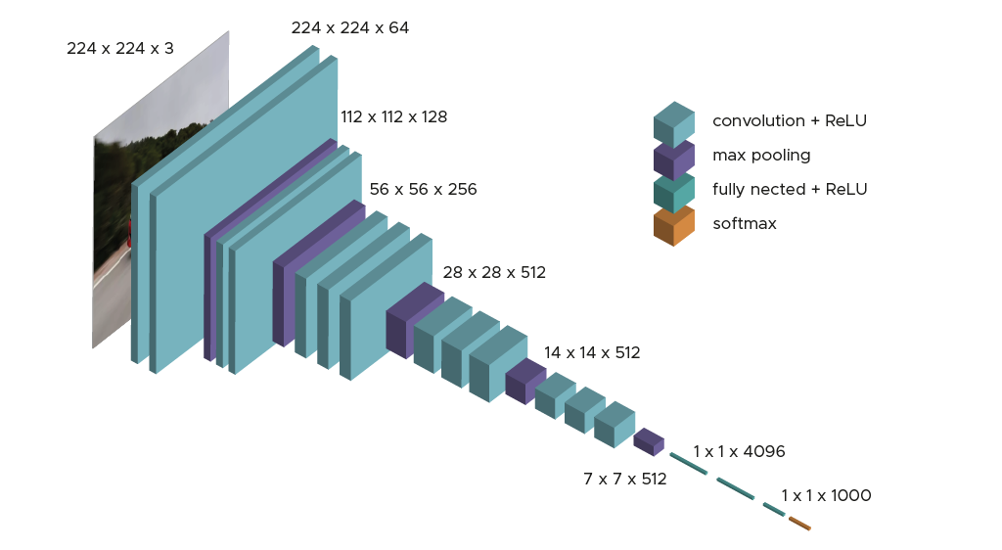

**MACHINE LEARNING DEPLOYMENT**

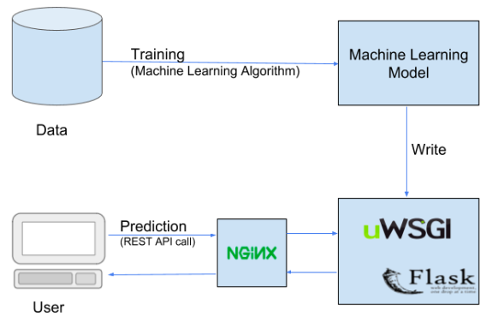

## DEEP LEARNING ARCHITECTURE

## 

## Problem algorithm: Random Forest

**Step 1:** Select random samples from a given data or training set.

**Step 2:** This algorithm will construct a decision tree for every training data.

**Step 3:** Voting will take place by averaging the decision tree.

**Step 4:** Finally, select the most voted prediction result as the final prediction result.

## System Requirements:

## Our system relies on a machine learning algorithm to predict input factors such as 10th-grade percentage, 12th-grade percentage, division, and the need for co-education and then displays the most suitable college for students.

## 

## We employed Deep Learning techniques to accurately predict whether the input image represents waste and, instead of discarding it, provide recycling instructions.

## And VGG16 is used for object deduction while enabling model with flask.

## Challenges Faced:

## Our project encountered challenges due to limited hardware, necessitating the use of cloud services(GPU ) like Google Colab for deep learning model training.

## Deployment of a Flask-enabled website posed compatibility issues, leading to delays. Acquiring extensive datasets for accurate food production surveys in India proved challenging, highlighting the need for improved data-sourcing strategies.

## Expected Result:

## COLLEGE PREDICTION: -

## If we provide our 10th,12th percentage, division, and coed it will predict the best college for us:

## 

## WASTE PREDICTION: -

## If we the upload the image in the webpage it will prodict the percentage the of the waste and the solution to avoid that.

## 

## FOOD PRODUCTION: -

## The statistical analysis of the food production in India is shown below:

## 

## Project Timelines:

|  |  |  |  |
| --- | --- | --- | --- |
| Description | Start date | End date | Status |
| Object Deduction(DL) | 26rd Aug 2023 | 29th Aug 2023 | Completed |
| College  Prediction(ML) | 27th Aug 2023 | 30th Aug 2023 | Completed |
| Chatbot | 29th  Aug 2023 | 31st Aug 2023 | Completed |
| Visualizing Food Scarcity in India | 30th Aug 2023 | 31st Aug 2023 | Completed |